THE STONEHENGE CUP
& EQUINOX CUP
2018
U.K. World Cup Free Flight Events
12/13th May 2018 Salisbury Plain
United Kingdom

World Cup Events

Saturday 12th May 2018 Stonehenge Cup F1A, B, C/P and Q
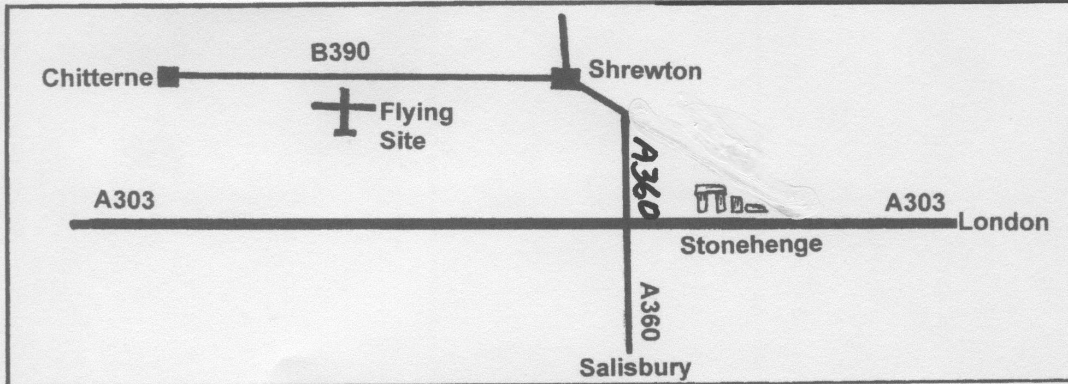Sunday 13th May 2018 Equinox Cup F1A, B, C/P and Q

Flying Site

The site is situated to the south of the B390 between Shrewton and Chitterne and will be signposted from the B390. GPS coordinates for the site entrance are 51°11’29.53”N, 1°57’32.59”W.

The terrain is undulating rough grassland crossed by dirt roads and tracks. The land is a military training area, which is carefully managed to preserve the history and wildlife. Model retrieval is usually on foot.

The area must be kept clean and tidy at all times and rules to protect the site must be observed.

Please note-there are no catering facilities available - competitors must bring their own food and drink.

Programme
Events will start at 09.00. There will be 5 rounds plus fly-offs flown from a flight line. The Max for round 1 will be 240 seconds. All other rounds will be 180 seconds Max. These maximum times and program may vary according to circumstances. All competitors will receive a gift.
Rules
The relevant section of the FAI Sporting Code will be followed.
All competitors must hold a valid FAI licence.
Entry Procedure
Competitors from the UK who wish to compete in either or both events need to post their entry forms to:-

Peter Martin, 23 Woodland Court, Dyke Road Avenue, Hove, UK, BN3 6DP complete with payment cheque made out to 'BMFA'.
Competitors residing outside the UK should email their completed entry form(s) to ffworldcupUK@gmail.com.

Overseas entry fees may be paid on the day in £, $ or Euros.
Entry forms must be received by not later than Friday 4th May 2018

Trophies
These will be awarded down to 3rd place for each class.
Timekeepers
Timekeepers will not be provided by the organisers for the rounds. Competitors must find their own timekeepers. Timekeepers will be allocated by the organisers for Fly-offs.

For further information please contact:-
Peter Martin or Richard Jack ffworldcupuk@gmail.com
Or Peter Tribe thepetertribe@gmail.com

Accommodation and Camping Information
Information is available on request from Peter Tribe:-
thepetertribe@gmail.com

STONEHENGE CUP AND EQUINOX CUP ENTRY FORM 2018

Full Name
Address
Town/City
Country |  | Post/Zip Code
Nationality |  | Senior/Junior
Telephone No. |  | Mobile No.
Email Address
FAI License and FAI ID Numbers |  | BMFA No.

World Cup Events

 | Stonehenge Cup |  |  |  | Equinox Cup
Day | SAT  12th | SAT  12th | SAT  12th | SAT  12th | SUN  13th | SUN  13th | SUN  13th | SUN  13th
Class | F1A | F1B | F1C/P | F1Q | F1A | F1B | F1C/P | F1Q
Please tick

Entry Fees

World Cup Event Single Class (Seniors) | €25/£20/$30
World Cup Event Single Class (Juniors)  (Junior aged 18 or under on 31st Dec 2018). | FREE
Additional classes within each Event (Seniors) | €12/£10/$15
Additional classes within each Event (Juniors) | Free
 | Total Paid*
(*Entry fee is included in the UK Contest License Holders fee, no additional payment is required)

UK Competitors post to - Peter Martin, 23 Woodland Court, Dyke Road Avenue, Hove, UK, BN3 6DP complete with payment cheque made out to 'BMFA'.

Competitors resident outside of the UK should email their completed entry form(s) to ffworldcupUK@gmail.com

